## Using Virtual Machine Extensions

### Lab Overview

In this lab, you will execute several PowerShell scripts that will in turn run PowerShell Desired State Configuration (DSC) scripts to customize each of the virtual machines that were created in the previous labs.

### Exercise 1: Customize the Virtual Machines

In this exercise, you will use the PowerShell ISC Extension to customize the webservers and the SQL Server.

1. From within the RDP session (LABVM), open Internet Explorer and navigate to https://portal.azure.com. Open to the **OpsVMRmRG** resource group by clicking **Resource Groups** and then clicking the resource group name. You can also access by clicking **Browse -> Resource Groups**.



2.

Click the

**WebVM**

**-**

**1**

vi

rtual machine.

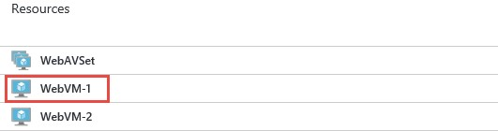

1. On the **Settings** blade, click **Extensions**.

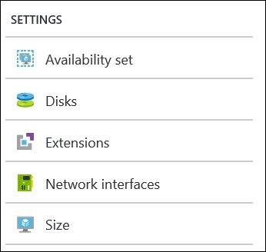

1. Click **Add** on the toolbar.



1. Click the **PowerShell Desired State Configuration** tile.



1. Click **Create**.

1. Specify the following configuration for the extension and click **OK**.

|  |  |
| --- | --- |
| For Configuration Modules or Script, browse to  **C:\OpsgilityTraining\WebConfig.zip**    Module-qualified Name of Configuration **web-dsc-config.ps1\Main**    Data Collection  **Enable**    Version  **2.0**    Auto Upgrade Minor Version  **Yes** |  |

1. Repeat steps 1-7 on **WebVM-2**.

1. Repeat steps 1-6 on **SQLVM-1**, and then use the following settings for the extension configuration.

|  |  |
| --- | --- |
| For Configuration Modules or Script, browse to  **C:\OpsgilityTraining\SQLConfig.zip**    Module-qualified Name of Configuration **sql-dsc-config.ps1\Main**    Data Collection  **Enable**    Version  **2.0**    Auto Upgrade Minor Version  **Yes** |  |

### Exercise 2: Explore the Extension Logs

1. From with the Azure Management Portal, open the configuration for the **WebVM-1** virtual machine. Click the **Connect** button on the toolbar and login with the following credentials:
   * Login: **demouser**
   * Password: **demo@pass123**



1. From within the virtual machine, click the File Explorer icon:



1. Navigate to the **Plugins** folder under: **C:\WindowsAzure\Logs**. This is where virtual machine extension logs file will be stored and is the starting point for troubleshooting extensions.

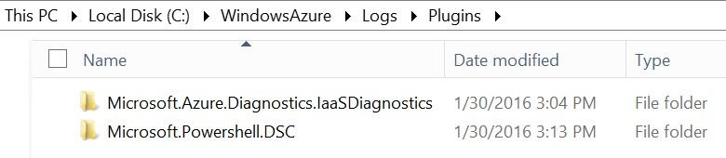

1. Navigate to the Microsoft.PowerShell.DSC\2.X folder and review some of the log files using notepad. This folder contains the log files for the PowerShell DSC extension that is customizing the virtual machine.
   * The CommandExecution* files are the log files for the handler environment code that executes the DSC script.
   * The DscExtensionHandler* files are the log files for the DSC script itself.

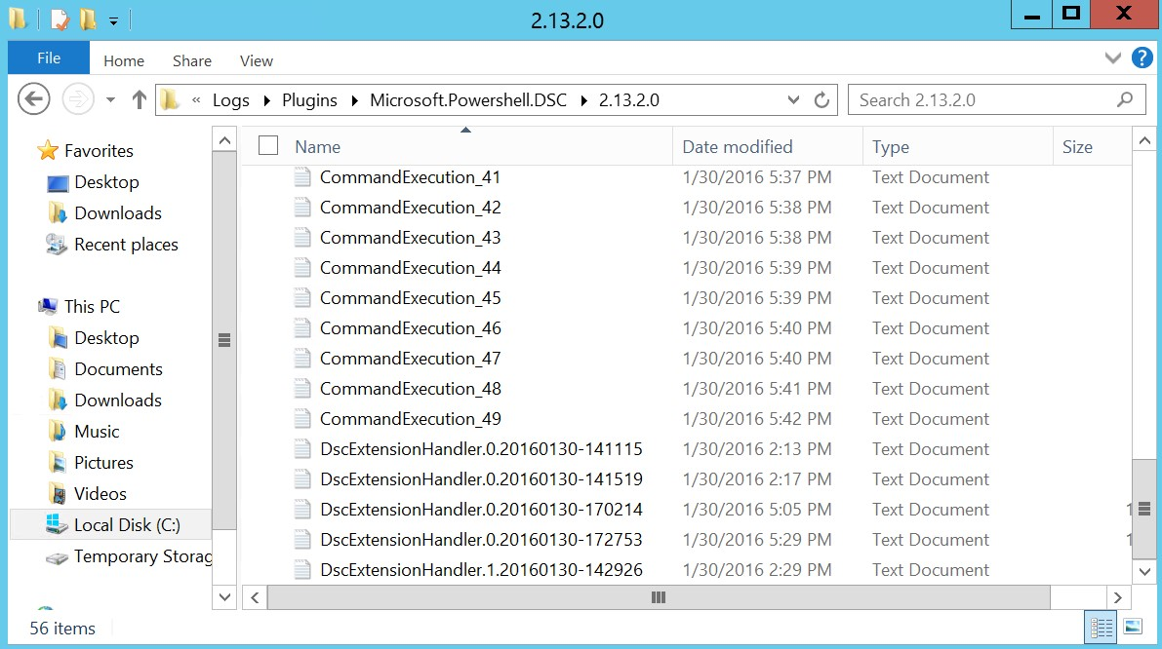

If an error occurs during extension execution the details will be in the log files.

### Exercise 3: Validate the Website is Working from WebVM-1

1. After the scripts have executed (**on all three virtual machines**) validate that the site will load by opening the configuration blade for **WebVM-1** in the Azure Management Portal and noting the Public IP address.



1. Navigate to the public IP using another browser tab to validate that the CloudShop app opens.

Summary

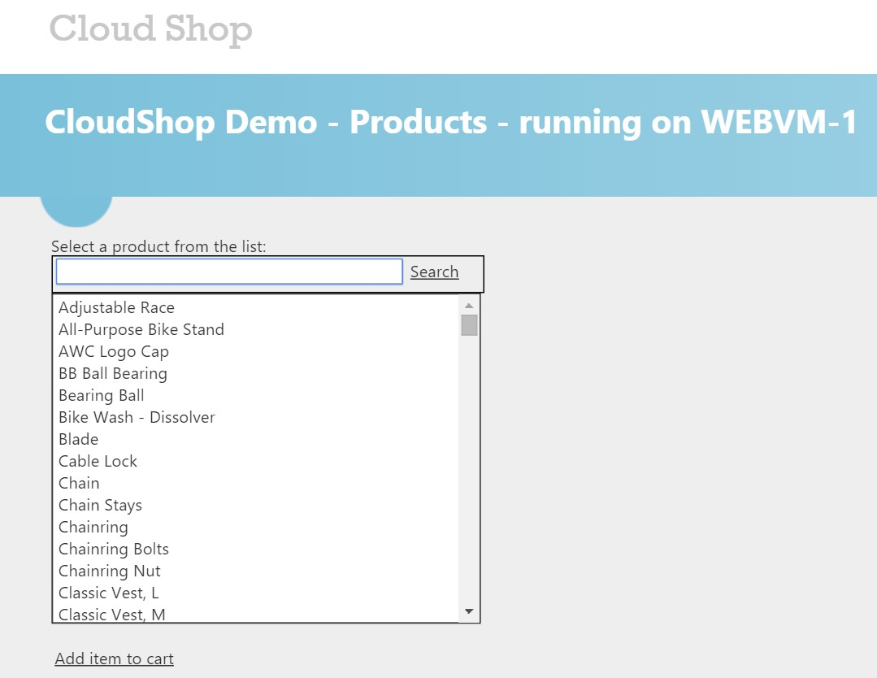

In this lab, you executed several PowerShell scripts that ran PowerShell Desired State Configuration (DSC) scripts to customize each of the virtual machines that were created in the previous labs.